Catering Cheese and Charcuterie Platters

Hops and Cheese are now offering our unique style of catering for your special events! Whether birthdays, anniversaries, parties or meetings we have a selection of fantastic platters that can feed small groups of 4 to 6 people or can be expanded to provide a cheese-centric feast for all your guests. Whatever the occasion it can only be made better by adding cheese!
Take a look at the information and pricing below and get salivating. Then please get in touch for more information regarding cheeses and charcuterie options available, guest numbers etc. and we can find the right options for you! You can create your own platters from our regularly updated product list or we would be more than happy to choose our favourites for you! We also have a lovely selection of Peter’s Yard crackers (including the charcoal variety!) and fresh ciabatta as optional extras.
We require at least 72 hours’ notice to ensure we have your chosen cheeses and fresh bread. All platters are available for collection or to order in advance if you have a private event in Hops & Cheese. Pre-payment is required and can be made by cash or card at Hops and Cheese or via BACs.

The Options – Platters
Cheese and Charcuterie Platters: Up to three cheeses, three types of charcuterie and/or pate served with nuts, dried and fresh fruits, olives, pickles, honey and chutneys.
Catering Cheese Platters: Up to five types of cheese accompanied by nuts, dried and fresh fruits, olives, pickles, honey and chutneys.
Charcuterie Platters: Up to five types of charcuterie and/or pate served with nuts, dried and fresh fruits, olives, pickles, honey and chutneys.
Additions: Fresh Farm Shop pies and antipasti classics olives, sundried tomatoes and stuffed peppers can also be added to your order.

Pricing
Cheese and Charcuterie
Serves | 4 to 6 | 8 to 12 | 16 to 20
Cost Per Platter | £27 | £54 | £108
Cost Per Person | £6.75 – £4.50 | £6.75 – £4.50 | £6.75 – £5.40
Charcuterie Only
Serves | 4 to 6 | 8 to 12 | 16 to 20
Cost Per Platter | £18 | £36 | £70
Cost Per Person | £4.50 - £3.00 | £4.50 - £3.00 | £4.38 – £3.50
Cheese Only
Serves | 4 to 6 | 8 to 12 | 16 to 20
Cost Per Platter | £22 | £44 | £86
Cost Per Person | £5.50 - £3.66 | £5.50 – £3.66 | £5.38 – £4.30
Bread and Crackers Packages |  | Pies | £1.75 per pie
Serves 4 – 6 | £8 | Olives | £2.25 per 100g portion
Serves 8 – 12 | £15 | Stuffed Peppers | £2.50 per 100g portion
Serves 16 – 20 | £30 | Sundried Tomatoes | £2.50 per 100g portion
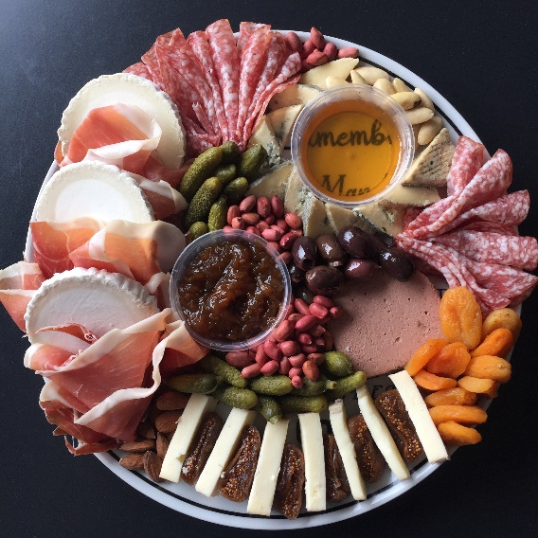
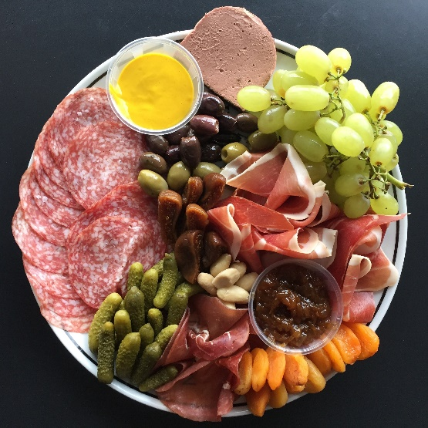
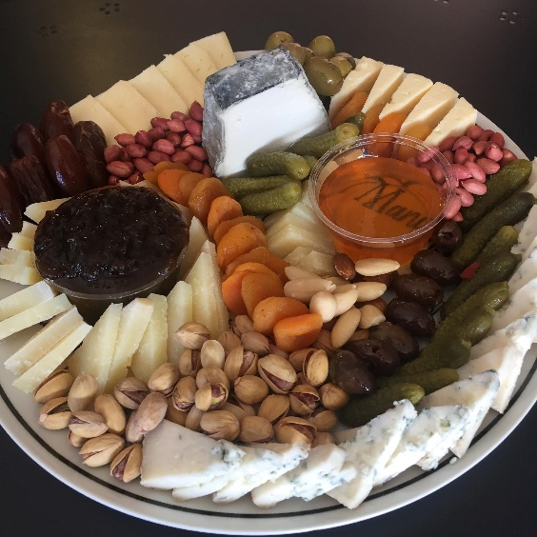
EXAMPLES
EXAMPLES OF PLATTERS THAT SERVE 4 – 6 PEOPLE.

